Tessella Project Number: 5951
Tessella plc 26 The Quadrant, Abingdon Science Park, Abingdon, Oxfordshire, OX14 3YS, UK
T: +44 (0)1235 555511 | F: +44 (0)1235 553301 | E: info@tessella.com | www.tessella.com

Client: Rutherford Appleton Laboratory

Mantid
General Information Catalog Detailed Design Document



Document Control
This document is under document control. All members of the distribution list will receive updated copies whenever alterations are made. All other copies are uncontrolled.

Document Owner
Name | Role | Company
Nicholas Draper | Owner | Tessella

Document Approval
The following are required to approve this document. Their approval signifies that the document is fit for purpose and approved for use. .
Name | Approval Role | Company
Sofia Antony | Developer | RAL
Stuart Campbell | Team Leader | ORNL

Distribution
Name | Role | Company
Mantid SVN repository | Filing | Rutherford Appleton Laboratory

Revision History
Author | Issue | Date | Description
Nicholas Draper | V1.R1.M0 | 13-Sep-2010 | 1st version written

References
Document | Ref | Date | Details & Issue
Architectural Design Document | [ADD] | 11-Nov-2009 | V1.R2.M1
Table of Contents
1 Introduction 4
1.1 Purpose of this Document 4
1.2 Scope of this Document 4
1.3 Context of this Issue 4
1.4 Definition of Terms 4
2 Detailed Design 5
2.1 Overview and Context 5
2.2 Class Structure 5

Introduction

Purpose of this Document
This document describes the detailed design of the Generalised Information Catalog searching components of the Mantid Framework.
It is based on the design specified in the Architectural Design Document [ADD]
It will form the basis of the development of this aspect of the framework and act as a guide for maintaining the system.

Scope of this Document
These requirements cover the development of the Generalised Information Catalog interface components of the Mantid Framework.

Context of this Issue
This is the first draft of the GIC-DDD derived from the ADD and after internal review will be updated and used as a basis for the development of the system.

Definition of Terms
ADD | The Architectural Design Document (this document), the high level design document for the entire system.
URD | The User Requirements Document, records the users’ requirements for the system.
SRD | The Software Requirements Document, specifies the behaviour of the software system.
API | Application Programming Interface, defines the interface through which two programs may interact.

Detailed Design

Overview and Context
The information catalog interface in Mantid was originally implemented only for ICAT version 3; however it has become clear that this will need to support multiple facilities using different back end information catalogs. Mantid will need to be able to support both a range of catalog implementations, but also be able to perform queries across multiple catalogs.

Class Structure
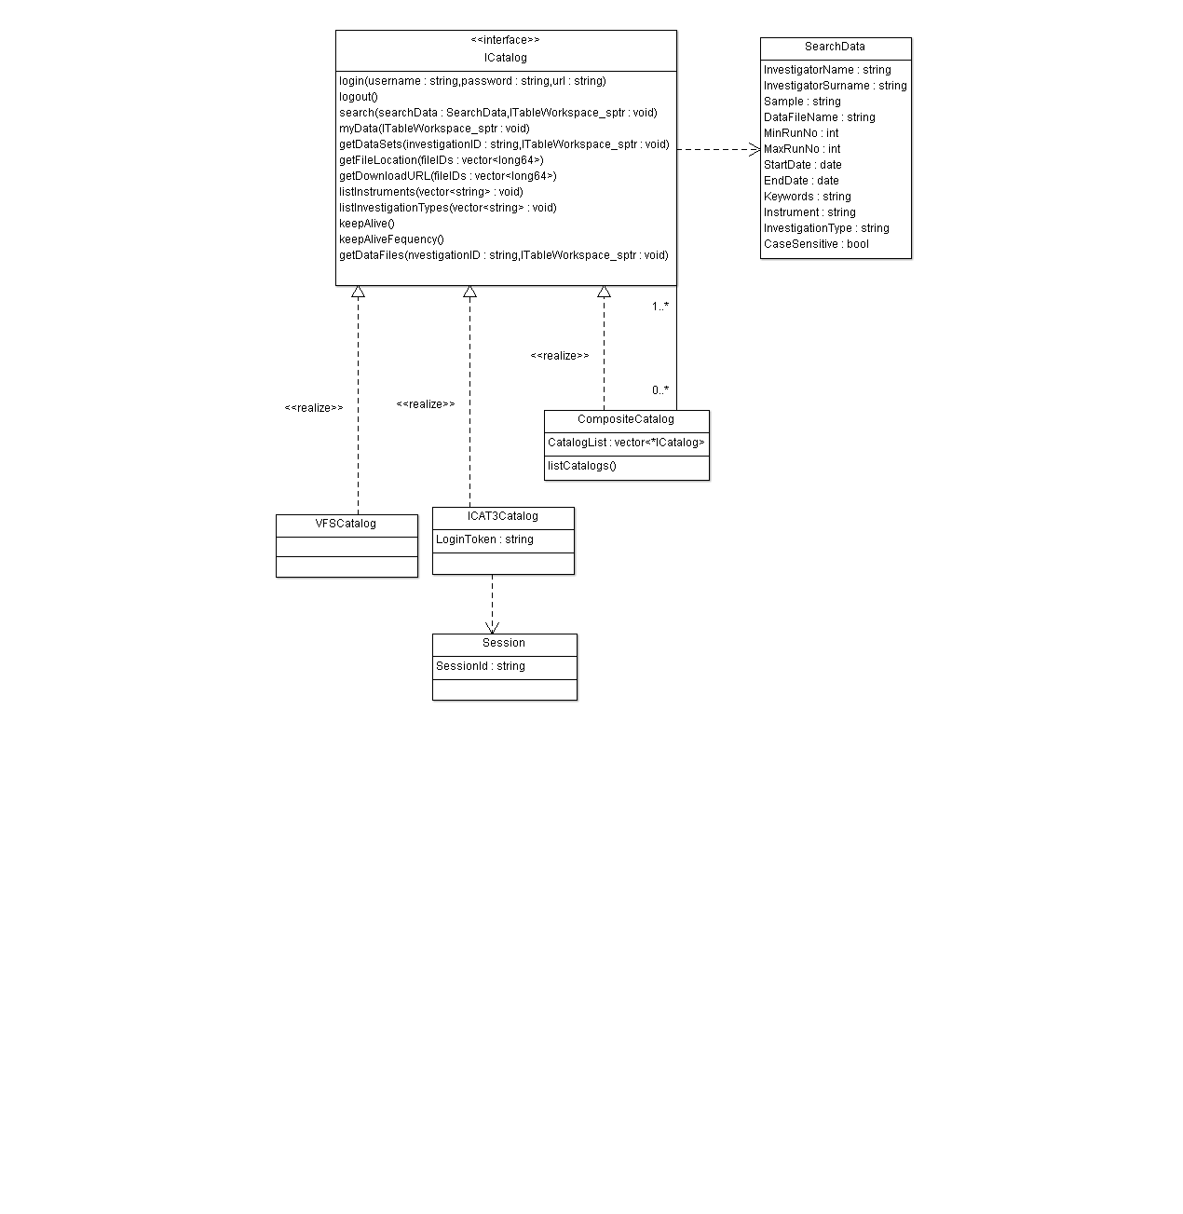

Session
This class is used by ICAT version 3 based catalogs to store the user session information like session id.

ICatalog
An implementation independent interface to multiple implementations of information catalogs. This should not contain any knowledge of the communication method or other implementation details. The keepAlive method should be a simple fast call whose result is ignored and is used simply to keep the logged in session alive. The keepAliveFrequency is the frequency in minutes that the keepAlive call should be made.
ICatalog Method | Request Parameters | Response Parameters | Usage | ICat API mapping
login | username(string), password(string) |  |  | login
logout |  |  |  | logout
search(searchData) | SearchInputs | TableWorkspace with columns: InvestigationId  RbNumber  Title  Type  Instrument  Investigator  RunRange  Year  Abstract  Investigators Name  Samples Name | Basic and Advanced Search. | searchByAdvanced
myData() |  | TableWorkspace same columns as search | My data search | getMyInvestigationsIncludes
getDataSets(investigationID : long64) | investigationId(long64) | Table workspace with columns: Name  Status  Type  Description  Sample Id | Data Sets Search | getInvestigationIncludes
getDataFiles(investigationID : long64) | investigationId(long 64) | Table workspace with Columns: Name  File Size  File Id  Format  Format Version  Format Type  Create Time | Data Files Search | getInvestigationIncludes
listInstruments() |  | A vector of Instrument Names | User Interface Pop-up boxes | listInstruments
listInvestigationTypes() |  | A vector of Investigation Types | User Interface Pop-up boxes | listInvestigationTypes
getFileLocation(fileID :long64) | fileID (long64) | file location as a path (string) | Down load button | getDatafile
getDownLoadURL(fileID :long64) | fileID (long 64) | download URL(string) | Down load button | downloadDatafile

SearchData
A class for passing the large number of possible search parameters to the ICatalog::search function.

VFSCatalog, ICAT3Catalog
These will be loaded as plug in implementations of the ICatalog interface. They will contain all of the specific implementation mapping and communication details.

CatalogFactory
The CatalogFactory (not shown) is an dynamic abstract factory for implementations of ICatalog indexed by the ICatalog::name method. This is a similar implementation to that used for UnitFactory.

CompositeCatalog
The CompositeCatalog class is a special implementation, not registered in the CatalogFactory. The CompositeCatalog implements the composite pattern, as such it maintains a list of one or more implementations of ICatalog, in response to any call to a method it forwards a call to each member of the list and amalgamates the responses before returning. Initially this will all be done within a single thread, but multi thread calling for each implementation may be added later.

